**Exercise 4: Functions**

**Scenario 1:** Calculate the age of customers for eligibility checks.

**Question:** Write a function CalculateAge that takes a customer's date of birth as input and returns their age in years.

CREATE OR REPLACE FUNCTION CalculateAge (

dob DATE

) RETURN NUMBER IS

age NUMBER;

BEGIN

SELECT EXTRACT(YEAR FROM SYSDATE) - EXTRACT(YEAR FROM dob)

INTO age

FROM DUAL;

RETURN age;

END CalculateAge;

DECLARE

CURSOR customer_cursor IS

SELECT customerid, name, dob

FROM customers;

age NUMBER;

BEGIN

FOR customer IN customer_cursor LOOP

age:=calculateAge(customer.dob);

DBMS_OUTPUT.PUT_LINE('CUSTOMER ID: '|| customer.customerid || ' NAME: '||customer.name||' AGE: '||age);

END LOOP;

END;

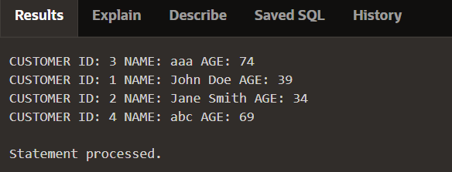

**Scenario 2:** The bank needs to compute the monthly installment for a loan.

**Question:** Write a function **CalculateMonthlyInstallment** that takes the loan amount, interest rate, and loan duration in years as input and returns the monthly installment amount.

CREATE OR REPLACE FUNCTION CalculateMonthlyInstallment(

loan_amount IN NUMBER,

annual_interest_rate IN NUMBER,

total_months IN NUMBER

) RETURN NUMBER

IS

monthly_interest_rate NUMBER;

emi NUMBER;

BEGIN

monthly_interest_rate := annual_interest_rate / (12 * 100);

emi := (loan_amount * monthly_interest_rate * POWER((1 + monthly_interest_rate), total_months)) /

(POWER((1 + monthly_interest_rate), total_months) - 1);

RETURN emi;

END;

DECLARE

CURSOR loans_cursor IS

SELECT loanid, loanamount, startdate,enddate,interestrate

FROM loans;

MonthlyInstallment NUMBER;

BEGIN

FOR rec IN loans_cursor LOOP

MonthlyInstallment:=CalculateMonthlyInstallment(rec.loanamount,rec.interestrate,MONTHS_BETWEEN(rec.EndDate, rec.StartDate));

DBMS_OUTPUT.PUT_LINE('LOAN ID: '|| rec.loanid || ' MONTHLY INSTALLMENT: '|| ROUND(MonthlyInstallment,2));

END LOOP;

END;

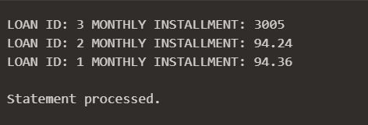

**Scenario 3:** Check if a customer has sufficient balance before making a transaction.

**Question:** Write a function **HasSufficientBalance** that takes an account ID and an amount as input and returns a boolean indicating whether the account has at least the specified amount.

CREATE OR REPLACE FUNCTION HasSufficientBalance (

cid IN NUMBER,

balance IN NUMBER

) RETURN BOOLEAN IS

current_balance NUMBER;

BEGIN

SELECT balance INTO current_balance

FROM accounts

WHERE customerid = cid;

IF current_balance >= balance THEN

RETURN TRUE;

ELSE

RETURN FALSE;

END IF;

EXCEPTION

WHEN NO_DATA_FOUND THEN

RETURN FALSE;

END;

DECLARE

CURSOR acc_cursor IS

SELECT customerid

FROM accounts;

customerid accounts.customerid%TYPE;

amount_to_check NUMBER := 500;

check_balance BOOLEAN;

BEGIN

FOR rec IN acc_cursor LOOP

customerid := rec.customerid;

check_balance := HasSufficientBalance(customerid, amount_to_check);

IF check_balance THEN

DBMS_OUTPUT.PUT_LINE('CUSTOMER ID: ' || customerid || ' HAS SUFFICIENT BALANCE: TRUE');

ELSE

DBMS_OUTPUT.PUT_LINE('CUSTOMER ID: ' || customerid || ' HAS SUFFICIENT BALANCE: FALSE');

END IF;

END LOOP;

END;

